WANDA BRYANT HOPE
Chief Diversity Officer
Johnson & Johnson

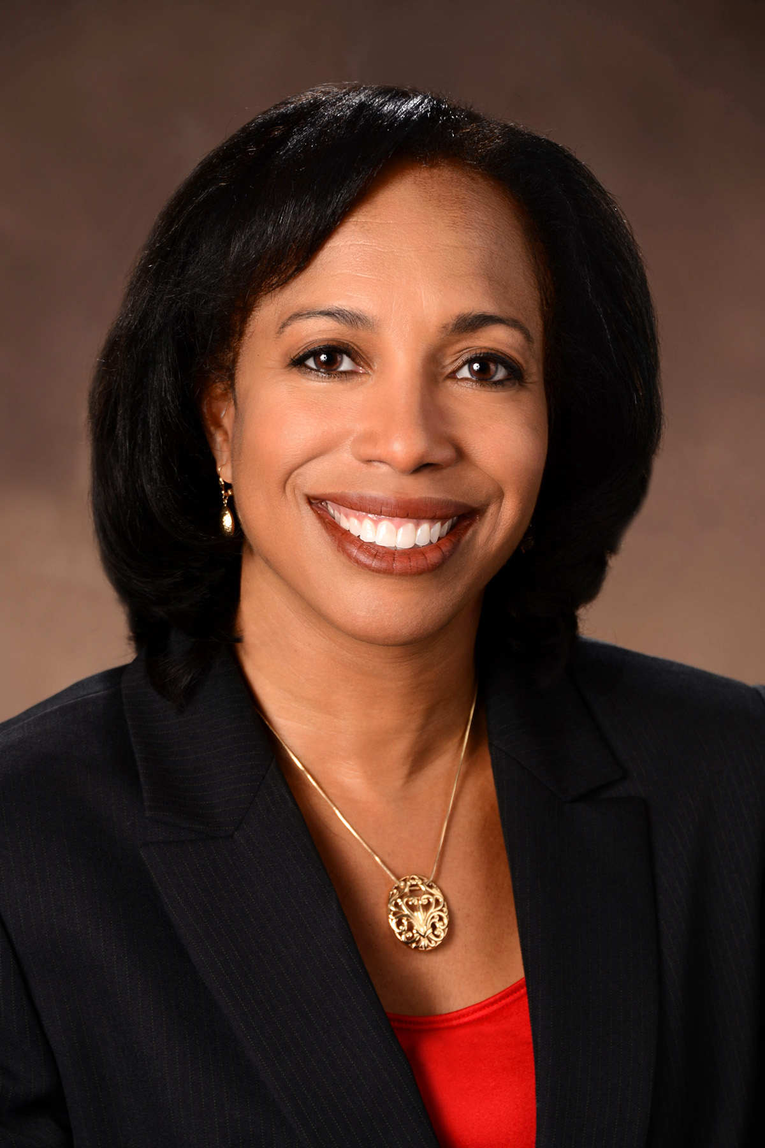

Wanda Bryant Hope is an accomplished business executive with significant experience in general management, marketing, sales, commercial operations, and human resources. Wanda is currently the Chief Diversity Officer for Johnson & Johnson worldwide. In this role Wanda is responsible for globally advancing J&J’s diversity and inclusion (D&I) outcomes, strengthening D&I capabilities, improving reputation, and driving innovation and growth for future success.

During her career Wanda has held a variety of leadership positions including Vice President, Sales & Marketing; Vice President, Commercial Analytics, Development & Operations; and Vice President, Global Performance & Development.

Wanda has been recognized for her ability to exceed business results, deliver innovative solutions to complex challenges, lead global change, and develop people for optimal results. Wanda has received several awards including the Healthcare Businesswomen’s Association’s Rising Star Award, the YWCA Tribute to Women in Industry Award, and the National Sales Network Community Service award.
Wanda received her Bachelor of Science degree in Marketing from The Pennsylvania State University. Wanda and her husband Bobby are the proud parents of their 9 year-old son, Tyler.

